Assignment -2

1.Being a user, I want to store certain document on S3.But, Apply a rule so that nobody can delete my document including administrator.

* Use Bucket Policy to deny the document deleting access

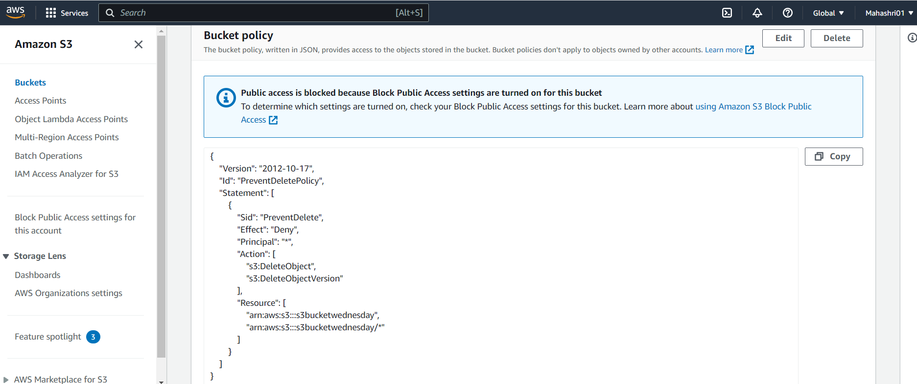

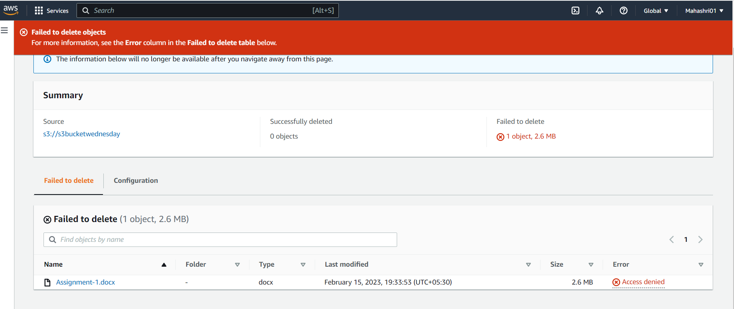

2.You have to create automatic way so that everyday 9PM my system one of the subfolder should be sync to S3.

1.Install AWS CLI

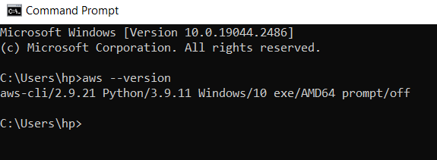

2.Create a S3 Bucket and a folder

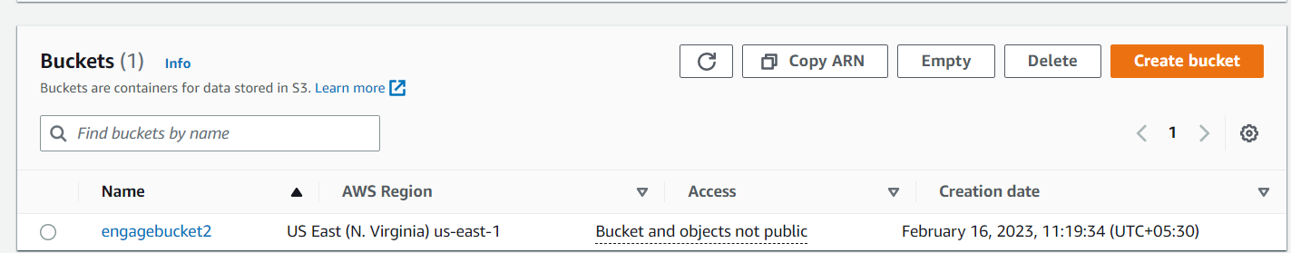

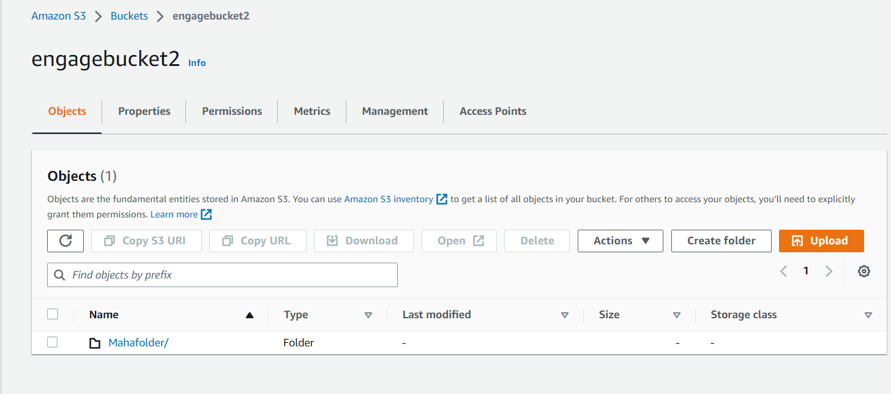

3. Create a sub folder in your local machine



4.Go to Task scheduler in your local windows machine and a create a new task

4.1 Provide task name

4.2 choose your user account in security group.

4.3 choose Run whether user is logged on or not option

4.4 Select your local machine windows version under configure for

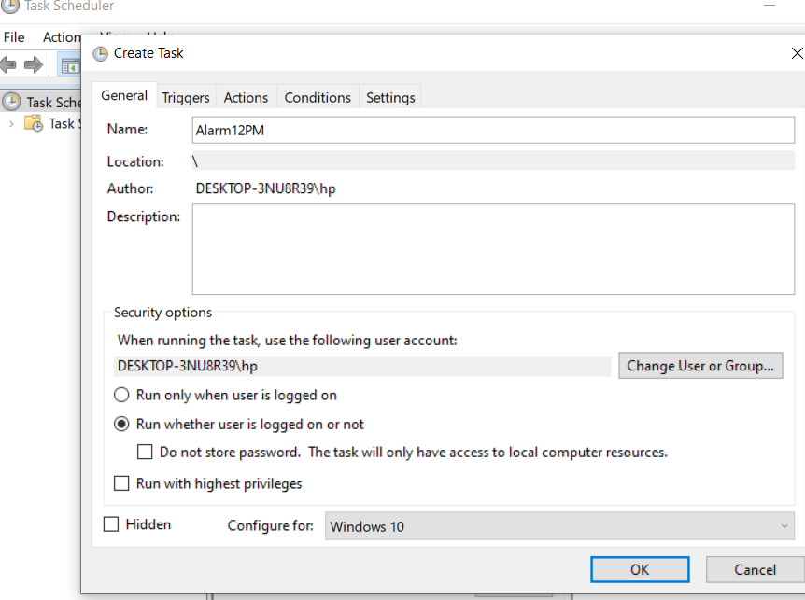

5.Go to Triggers Tab and set the time to 12:00PM or 9:00PM according to your need and choose generate daily option and click Ok

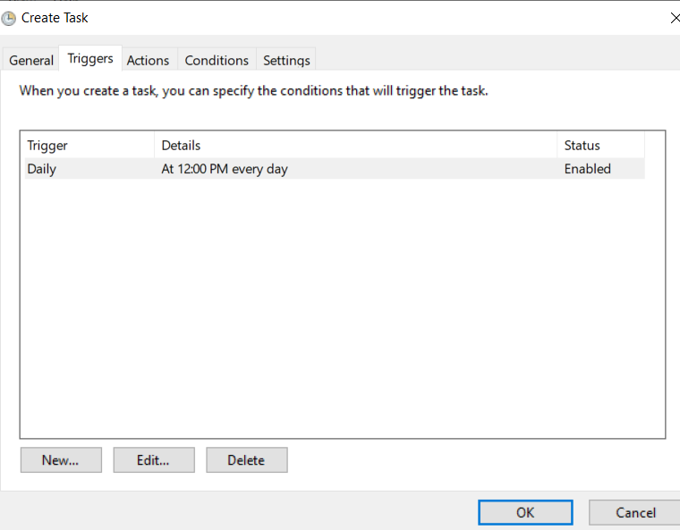

6.Go to Action Tab and choose start a program in action 🡪Browse the AWS CLI Program script 🡪Add the Arguments –

“ aws s3 sync D:\AWS Documents s3://engagebucket2/https://s3.console.aws.amazon.com/s3/buckets/engagebucket2?prefix=Mahafolder/&region=us-east-1 “

Where

D:\AWS Documents is Path of the folder in local machine

engagebucket2 is S3 Bucket name in AWS Console

https://s3.console.aws.amazon.com/s3/buckets/engagebucket2?prefix=Mahafolder/&region=us-east-1 is the link to the s3 bucket and folder inside it

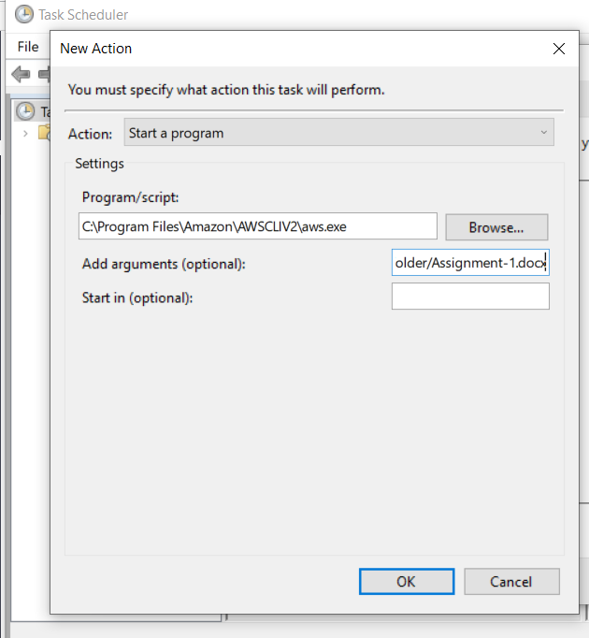

7.Task is created after providing username and password of the local machine to schedule the task.

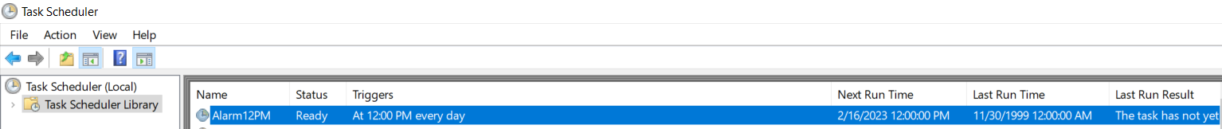

* This will automatically synchronize the subfolder to S3 at 12:00PM everday.